**A Report on**



“Celebreno”: a Web-based Application for Event Planning using ASP.net



**Maha**

**Mahmoud**

**150792**

**Under the supervision of**

**Mr. Ramakrishna Kumar**

# Abstract

Nowadays, the industry of events has become a core life part, which has resulted in rising many event planning companies. Each event varies in its nature and purpose. Thus, people feel confused to select the best for their demands, keeping in mind the difficulties faced in order to plan a successful event. A lot of time and money is therefore wasted. The exhaustion felt by the people, the waste of time in the search for the best event plan and the difficulty in supporting all the services needed in one place contributed to the increasing of this problem. Thus, the anticipated goal of this proposal is to develop an all-in-one web application for event planning, called “Celebreno”, using ASP.net and C#, wherein there are many event categories and services provided by different event planners, which will be a great way to assist people in planning a successful and economical event. This web application will allow people to get the needed information, regarding the services provided, cost, event type and event planners’ rate, from a single place. Besides, people will be able to compare between the event planners easily based on their provided services and cost to select the most suitable one. The application is implemented using Microsoft Visual Studio (VS) 2017 and a couple of features and techniques including bootstrap, asp.net identity and entity framework code first. This report covers a brief literature review of some of the previous relevant works, which are extremely useful for developing the web application. Followed by, the requirements analysis and the design of the application including the database diagram, flow chart, and User Interface (UI). It also covers the implementation details, result and discussion and the future work of the developed application. As can be seen, this report discusses the full development of Celebreno Web-based Event Planning Application.

**Key Words**: Event planning, Web application, ASP.net, C#, User Interface (UI)

Table of Content

Abstract i

List of Tables iv

List of Figures v

**Chapter 1:** Introduction 1

1.1 Background 1

1.2 Problem Description 1

1.3 Aim 2

1.4 Objectives 2

1.5 Project Scope 2

1.6 Project Motivation (Significance) 2

1.7 Project Feasibility 3

1.8 Project Challenges 3

1.9 General Project Constraints 3

1.10 Project Benefit 3

**Chapter 2:** Literature Review 5

Summary 7

**Chapter 3:**  Software Development Model 9

**Chapter 4:** Requirements Gathering 13

4.1 Business Level Requirements 13

4.2 User Level Requirements 13

4.3 Product Level Requirements 14

**Chapter 5**: Design 15

5.1 Database Diagram 15

5.2 Flowchart 15

5.3 Interface Design 17

**Chapter 6:** Implementation Details 19

**Chapter 7:**  Result and Discussion 24

**Chapter 8:** Conclusion 28

**Chapter 9:** Future Work 29

References 30

# 

# List of Tables

**Table.2.1**: A comparison between the two systems.……………………………….…8

# List of Figures

**Figure2.1:** System design of the web application 5

**Figure2.2:** The User Interface of the web application on the mobile 6

**Figure2.3:** The User Interface of the system 7

**Figure3.1:** A comparison between Agile and Waterfall models 9

**Figure3.2:** The process of development in the agile model 10

**Figure5.1:** The Class Diagram of Celebreno 15

**Figure5.2**: The flow chart of buying a service package in Celebreno 16

**Figure5.3:** The home page of Celebreno Web Application. 17

**Figure5.4**: The login form of Celebreno Web Application 18

**Figure5.5:** Our Services Web Page of Celebreno Web Application. 18

**Figure5.6**: The Administration Page of Celebreno Web Application 18

**Figure6.1:** The Code First Approach in Entity Framework. 20

**Figure6.2:** The classes created for the database of Celebreno 20

**Figure7.1:** The registration form of Celebreno 25

**Figure7.2:** The login form of Celebreno 25

**Figure7.3:** Our Services Page of Celebreno 26

**Figure7.4:** The Shopping Cart of Celebreno 26

**Figure7.5:** The Administration Page of Celebreno 27

# Chapter 1: Introduction

## Background

Event planning is the process of coordinating an event such as a party, convention, wedding or meeting. This process includes the arrangement of food, decor, transportation and guest list. It also includes booking a venue, coordinating the activities of event personnel, supervising at the site, and choosing a theme for the event. In brief, event planning means coordinating every detail of the event, from the venue “the first step” to the last step in the process of the planning. Nowadays, the event industry has become a key part of life, resulting in an increasing number of event planning and management companies. Each event varies in its nature and purpose; hence, the process of each plan differs regarding the type of the event. The person who takes responsibility for the coordination and execution of the event called an event planner. (International Institute of Event Management, 2017)

In this report, the developed web application, Celebreno, will serve the functionality of the event planner to ease the process of planning events. In this application, users will get all the resources, which are needed for planning, at a single place instead of wondering around them in many places. Besides, this application will comprise the coordination of all the activities and tasks that are required for the execution of an event.

## Problem Description

The last few years have been a rapid growth in the event planning industry, which has resulted in rising many event planning companies. Thus, people feel confused to select the best for their demands, keeping in mind the difficulties faced in order to plan a successful event. (Oden C., 2016) A lot of time and money is therefore wasted. The exhaustion felt by the people, the waste of time in the search for the best event plan and the difficulty of supporting all the services needed in one place, contributed to the increasing of this problem. (AjayKumar, Taher & Kasture, 2018) Therefore, there is an urgent need to develop a system, which can assist people in planning a successful and economical event. (Rennie, 2018) By developing this web application, people will be able to get all of what they need from a single place, which is something that has never been developed before.

## 1.3 Aim

To develop a web application for event planning using ASP.net wherein there are many services provided by different event planners.

## 1.4 Objectives

* To study and review the current event planning web applications.
* To study the development of web applications critically.
* To determine the major requirements of Celebreno Web Application.
* To design the structure of Celebreno Web Application.
* To develop Celebreno Web Application using asp.net with C#.
* To provide the functionality of online event planning.
* To test and validate the web application.

## 1.5 Project Scope

Celebreno Web Application will allow people to get the needed information, regarding the services provided, cost, event type and event planners’ rate, from a single place. This application will be available anywhere and anytime. Besides, it can work smoothly in any browser and any Operating System (OS). Furthermore, it is compatible with any mobile browser regardless of its type.

## 1.6 Project Motivation (Significance)

Celebreno Web Application will allow people to get the needed information, regarding the services provided, cost, event type and event planners’ rate, from a single place. Besides, people will be able to compare between the event planners easily based on their provided services and cost to select the most suitable one. Hence, a good decision can be taken and a successful event can be planned. Furthermore, this web application will help in reducing the workload on people who have not any experience in event planning. Equally important, it benefits in reducing the environmental impact by minimizing paper wastage and consumption, as well as reducing air pollution by conserving car fuel since users will get all of their requirements from the web application without the need of going anywhere.

## 1.7 Project Feasibility

Celebreno Web Application requires Microsoft Visual Studio (VS) 2017 software, which is open-source software and free to use. In addition, VS is available in national university college labs.

## 1.8 Project Challenges

The most challenging task to be performed in this project is making the Web Application compatible with all browsers, as well as achieving high performance in loading the web pages fast. Furthermore, the application should be scalable to balance the load between the servers successfully. Besides, testing the web application’s usability, functionality, interface, performance, compatibility and security needs to be accomplished within a short period of time, which may require more time and effort than expected.

## 1.9 General Project Constraints

Managing constraints plays a big role in ensuring that the project will be completed within the specified time, and with the suitable allocated resources. Quality, time and risks are some of the main constraint, which may impact the project. These three constraints are interrelated to each other since making a change in any of them will affect the other two. For example, making a change in quality will definitely affect the project’s time. As well as, making a change in time, may decline/ decrease the quality of the project. Further, risks must be foreseen at every step of the project with proper preparations to overcome them. (WorkFront, 2018)

## 1.10 Project Benefit

The way of generating revenue from the Web Application is something needs to be considered while developing it. According to (Kryzhanovska , 2019), people are more likely to use free applications over a paid application. Therefore, it is decided that Celebreno will be free to use. However, Celebreno will be a free Web Application, getting the benefit of it could be with three main strategies, which are:

* **In-App Ads**

Allowing ads in web applications is one of the most common ways of earning money with apps. The placements of the ads should be considered carefully to maintain user satisfaction and experience. The best example of this is the banner ads since it consumes a small part of the screen so the user will not get annoyed. In order to monetize Celebreno through Ads, AdSense network will be used to display native ads for Celebreno users. In this strategy, the amount of money earned is calculated by the number of times users click on an ad. (Kryzhanovska , 2019),

* **Freemium**

The key concept of this strategy is to make a paid version of Celebreno Web Application, which includes more features than the free version. Users of Celebreno will be offered to upgrade to the paid version for an improved experience. Users can get the benefit of advanced options or features such as eliminating or blocking ads. (Gleb, 2019)

* **Email Marketing**

This strategy is working by asking Celebreno users to provide their e-mails when they register and adding a Facebook login option so that emails will be collected and added to a subscription list. (Gleb, 2019)

# Chapter 2: Literature Review

This chapter focuses on several examples of past works carried out in recent years with a view to enhancing the growth of the development of Online Event Planning Systems. It clearly indicates and analyses the aim, methodologies, strengths and results of the papers reviewed. In addition, other essential parameters include limits to be overcome while the application is being developed, and the range of further investigations, which should be considered if possible, for Celebreno application.

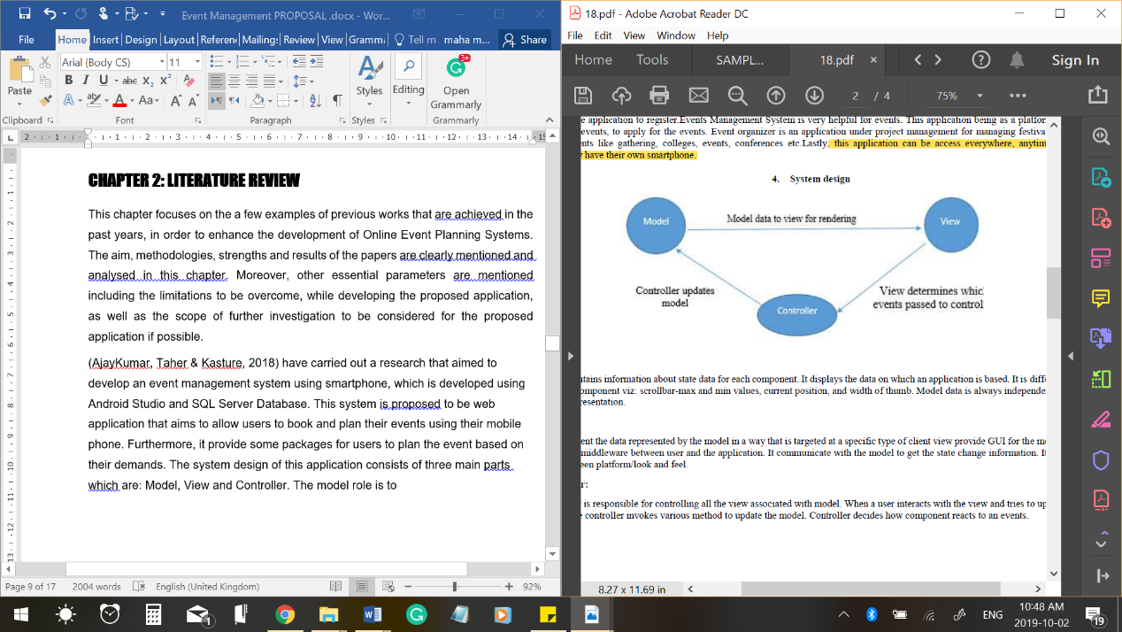(AjayKumar, Taher & Kasture, 2018) have carried out research that aimed to develop **an event management system using smartphone**, which is developed using Android Studio and SQL Server Database. This system is proposed to be a web application that aims to allow users to book and plan their events using their mobile phones. Furthermore, it provides some packages for users to plan the event based on their demands. The system design of this application consists of three main parts, which are Model, View and Controller “As shown in **Fig2.1**”.

**Figure2.1**: System design of the web application.

(AjayKumar, Taher & Kasture, 2018)

**As a result**, the application has been successfully tested and developed. The application **has some strengthens** including the 24/7 availability as everyone has their own smartphones and the ease of booking an event. **However**, the system has some limitations such as:

* The failure to provide a user-friendly GUI.
* The limited services provided to the user.

This event management **system can be enhanced by** redesigning the User Interface (UI) to make it more attractive and easy to understand, providing more services to the user and adding the feature of searching and filtering the results. The figure below **“Fig2.2”** shows the UI of the system.

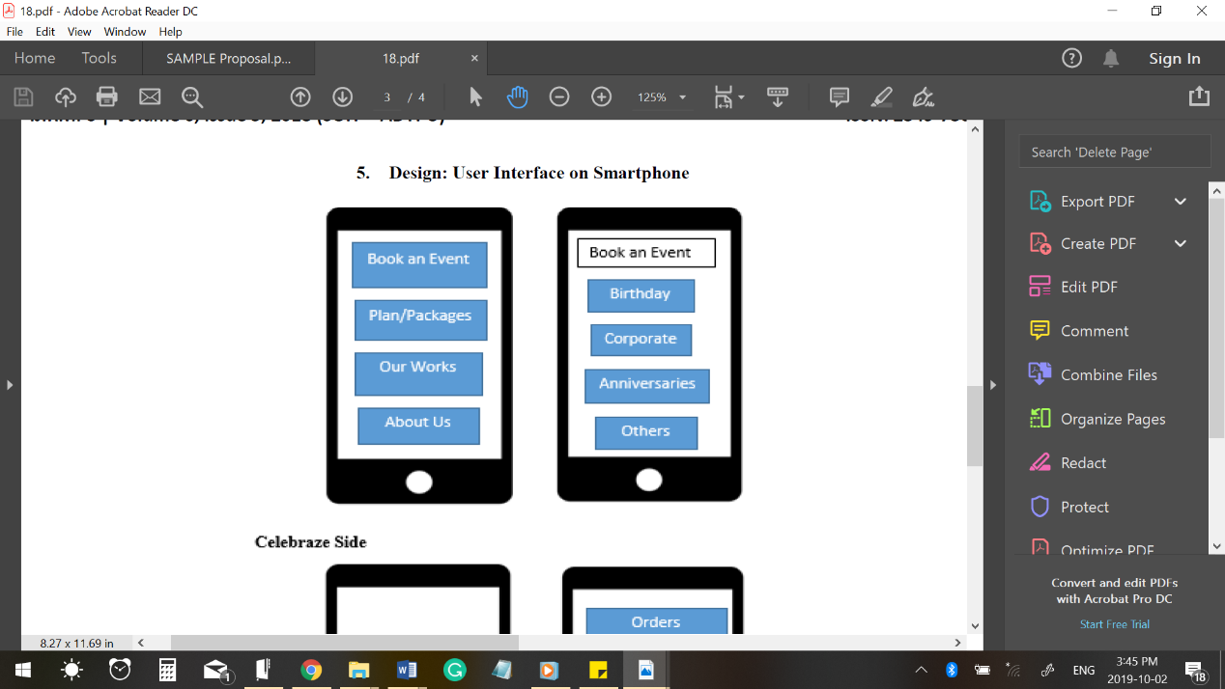

**Figure2.2**: The User Interface of the web application on the mobile.

(AjayKumar, Taher & Kasture, 2018)

One more existing related software is **GEMS: a Generic Web-Based Event Management System**, which was developed by **Binti & Ghani in 2016**. This system aimed to create a web-based useful event management system named Generic Event Management System (GEMS), which helps users in every environment to manage their events. This system has three main users, which are organizer, admin and user. Each user has a different role and privileges. The role of the organizer is to submit proposals for organizing an event as per the requirements mentioned in the user request so that registered users can select the most suitable proposal based on the information given in the proposal submitted by the organizers. Besides, the role of the admin is to manage this process between the user and the organizer.

**As a result**, the GEMS system has been successfully achieved a satisfaction to the users. **Fig2.3** shows the interface of the system, where a list of events is displayed. Furthermore, **the system has strengthens** including its ease of use, attractive user interface and productivity since it follows the Rational Unified Process (RUP) that prevents resources from being wasted as well as reduce the cost of the development by eliminating unused resources. **However**, it has some limitations including the disability to provide other options for the user if no proposals submitted regarding his request. In addition, the system does not support online payment option. Even so, this **GEMS system can be enhanced by** providing more options and services to users, so that they can get all of they want from the system. (Binti & Ghani, 2016)



**Figure2.3**: The User Interface of the system.

(Binti & Ghani, 2016)

## Summary

Based on the previous studies of the above two papers, it is found that the GEMS system is more effective than the (AjayKumar, Taher & Kastures) System. However, both of the systems are disabled to provide the user with the best services or resources needed for planning the event. The table below “**Table2.1”** shows a comparison between the two systems, which have been reviewed. In addition, both of the systems do not support online payment feature. It would be better if they provide the user with more than one option to let him compare and select the most suitable option. For this reason, Celebreno Web application will be developed to overcome this problem and help the user in planning his event in the way it suits him since the user will have many options to plan the event either by selecting a single service or a package of services. Furthermore, the application will provide many other services that will be discussed in detail in the next chapter.

**Table2.1**: A comparison between the two systems.

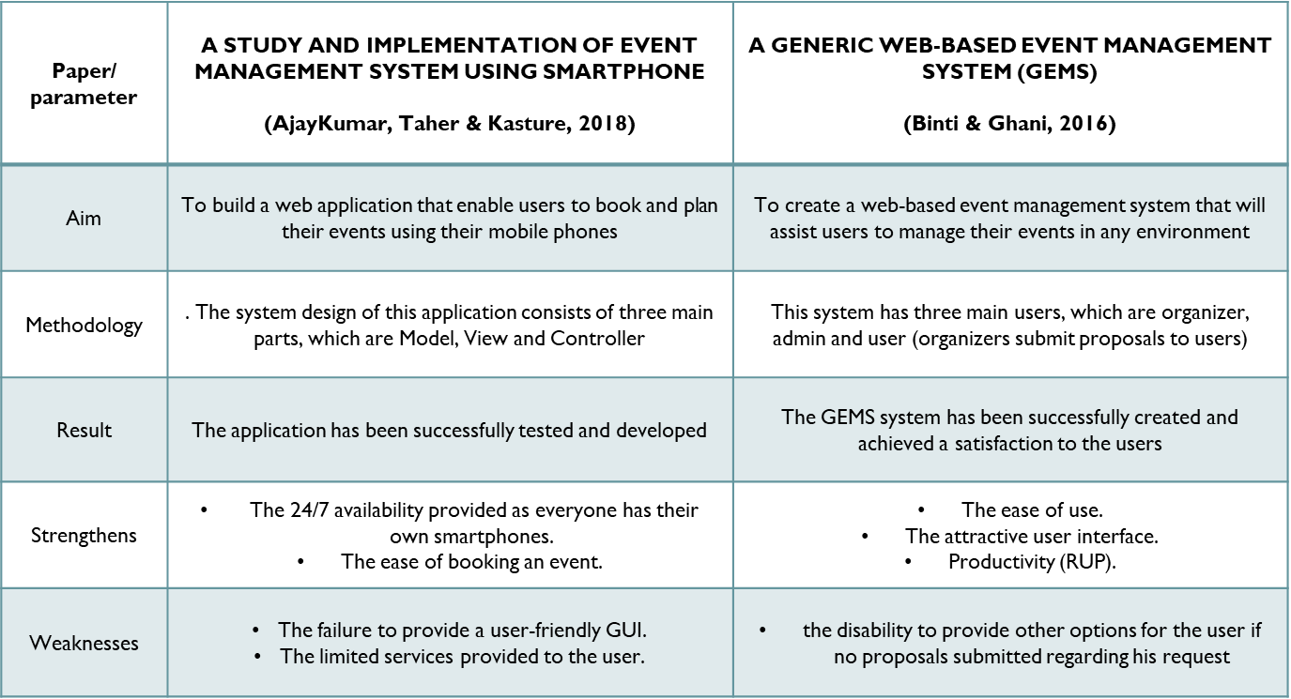

# Chapter 3: software development model

The Agile SDLC model is the Software Development Lifecycle used to develop the web application. Agile SDLC is selected for many purposes, which are:

* Reduces the risk by generating a short period of time boxes/iterations.
* Frequent changes are allowed.
* Accuracy is increased as faults can be found earlier and corrected. (Existek, 2017)
* The first product version can be released quickly
* The development steps are not considered as large sequential steps. Rather, it makes all processes ongoing.

In addition, the Agile Model has achieved a high success rate above the Waterfall success rate, according to a study carried out by the Standish Group “As shown in **Fig3.1”.** (Kukhnavets P., 2016)

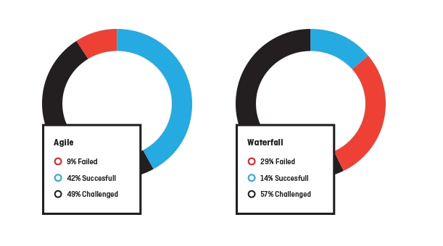

**Figure3.1**: A comparison between Agile and Waterfall models.

(Kukhnavets P., 2016)

**However**, Agile Model has few disadvantages including:

* The current system architecture could be affected by new requirements.
* In some cases, system changes may exceed the anticipated time. (Existek, 2017)

**To conclude,** Agile is best for Celebreno Web Application since it offers greater flexibility and incremental iteration as well as requirement modification. The accompanying diagram “**Fig3.2**” illustrates the implementation phase in the agile model.

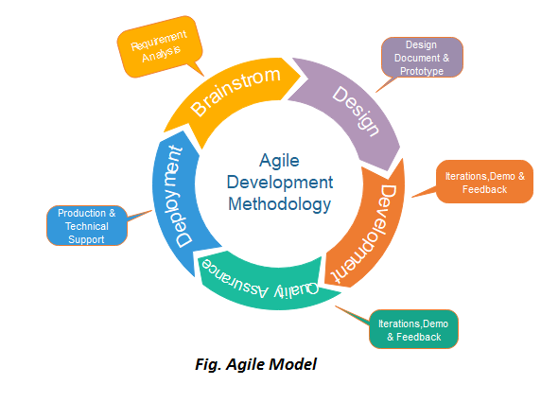

**Figure3.2**: The process of development in the agile model.

(Javatpoint, 2019)

In web applications**, the process of software development** goes through core phases, which are:

* **Planning (Requirement Gathering) and analysis:**

This step involves gathering and analyzing the requirements of the web application and studying previous related works. Then, convert the gathered requirements into a software design plan. (Tyagi G., 2018) Furthermore, it involves estimating the time needed to complete the project, sketching the initial interface design and logo. At last, a feasibility study of the application is conducted. (Javatpoint, 2019)

* **Design and Prototyping:**

This step involves outlining a quick architecture (prototype) of the web application, as well as the database, which can be extended and reviewed easily. Then, the application will be tested and reviewed in terms of the requirement. (Tyagi G., 2018)

* **Implementation:**

This step involves the real developing of the web application with data recording going on the background. In addition, it includes establishing the interface and functionality of the application, as well as integrating the database. In addition, finalizing the development of all the modules of the web application such as registration, venue and price should be done during this step. Besides, implementing the frameworks, CMS and SEO tools used for the web application. The development of the “Celebreno” web application takes place for the front and back end as the following:

* **The Front End:** ASP.net using C# language.
* **The Back End:** Relational Database Management using SQL Server Management Studio. (Javatpoint, 2019)
* **Testing:**

This crucial step involves testing each part of the application including the User Interface (UI) design and the functionality. The web application will be checked completely from end-to-end by the following testing:

* **Functionality Testing:**
  + Check all the links including internal, external, mail and broken links.
  + Check the validation of each field in the web forms.
  + Check the error message for the wrong inputs.
  + Check the database integrity and consistency when a database functionality is done.
* **Usability Testing:**
  + Check if the web application is easy to use (user-friendly).
  + Check the consistency of the web application.
  + Check the navigation to and from different controls.
  + Check the content of the web application including spelling errors and text colour matching.
* **Interface Testing:**
  + Test the compatibility of the server with network, software, hardware and the database.
  + Check the interaction between the web server and the application server.
  + Check the interaction between the application server and database server.
* **Compatibility Testing:**
  + Check the Browser compatibility of the web application by testing the web pages on different browsers.
  + Check the Operating System (OS) compatibility of the web application by testing the web pages on different OSs.
  + Check the mobile compatibility of the web application by testing the web pages on different mobile browsers.
* **Performance Testing:**
  + Check the web application’s performance on different internet speed and stress.
* **Security Testing**:
  + Check for the ability of password cracking.
  + Check the reaction of the system to all invalid inputs.
  + Check if internal pages can be accessed without logging. (Software Testing Help, 2019)

# Chapter 4: requirements Gathering

Requirements management is one of the most important steps in developing Celebreno Web Application since it plays a big role in the success of the application. Miss-understood or uncompleted requirements may lead to the greatest risk of the project. The following are the main types of requirements of Celebreno Web Application:

## 4.1 Business Level Requirements

These requirements define the objectives and the problems that are intended to be addressed by Celebreno Web Application. In addition, it sets out the business needs in terms of business initiatives and activities. Business level requirements of Celebreno relies upon the string need of an event planning platform that enables users to choose and compare between a number of event management’s service packages, in order to ease the way of planning an event. According to (Oden C., 2016), people feel confused to select the best way plan of an event for their demands, keeping in mind the difficulties faced in order to plan a successful and economical event. Therefore, there is an urgent need to develop the Web Application, which will allow people to get all of what they need from a single place, which is something that has never been developed before. For these reasons, the business demand for Celebreno is immense and connected to its feasibility. (Garima, 2019)

## 4.2 User Level Requirements

User Requirements can be classified into a functional and non-functional requirement. They can be gathered using many techniques such as conducting meetings and interviews. The following are some of the main **functional requirements** of Celebreno Web Application:

* Users should be able to register in the web application and login if they already have an account.
* The web application should not allow customers to access the administration and provider pages.
* All users of the web application should be able to view the Service Packages.
* Customers must be able to add service packages to the shopping cart.
* Customers should be registered to add a service package to the shopping cart.
* Customers should be able to purchase service packages.
* Admin should be able to add, remove, update and view all service packages.
* Providers of service packages should be able to add, remove and update their own service packages.
* Each provider should have access to his packages only, and should not access other providers’ packages.
* Each user of the web application can manage his account including changing their account passwords.
* All inputs in the web application must be validated before sending to the server.
* Each user of the web application must have a unique ID (Username).
* Customers should be able to update the shopping cart including removing a service package and changing the number of each item in the cart.

**Non Functional requirements** of Celebreno could be:

* **Availability**: the web application should be available 24/7.
* **Capacity**: the web application should be able to support a load of 1000 users at the same time.
* **Performance:** the application should respond within maximum 3
* **Maintainability and Safety** and: a backup of the web application and its database should be performed regularly.
* **Accessibility**: Customers, admin and event providers can access the web application, but the user's access level is regulated according to its scope of use.

## 4.3 Product Level Requirements

Product level requirements analyse the functionality and working principle of Celebreno Web Application. It is also called system requirements. The web application is developed using C# and asp.net. It will operate/run on a server and communicates in real-time with the clients of Celebreno. (Techopedia, 2019) The following are some of the product level requirements:

* The web application should run smoothly with at least 700 MB of RAM, Random Access Memory.
* The web application requires 600 Kbps minimum speed of the Internet.
* The web application needs internet access.

# Chapter 5: Design

## 5.1 Database Diagram

UML Class Diagram is used to represent the database of Celebreno Web Application in the form of a diagram. UML Class diagram is used to represent the system’s static structure of classifiers. It consists of a number of classes along with their relationships with each other. In Celebreno Web Application, the database consists of eight classes “ As shown in **Fig5.1**”, five of them are for storing users’ credentials in the application, and the other three are for representing the service packages and the items/ service packages in the shopping cart.

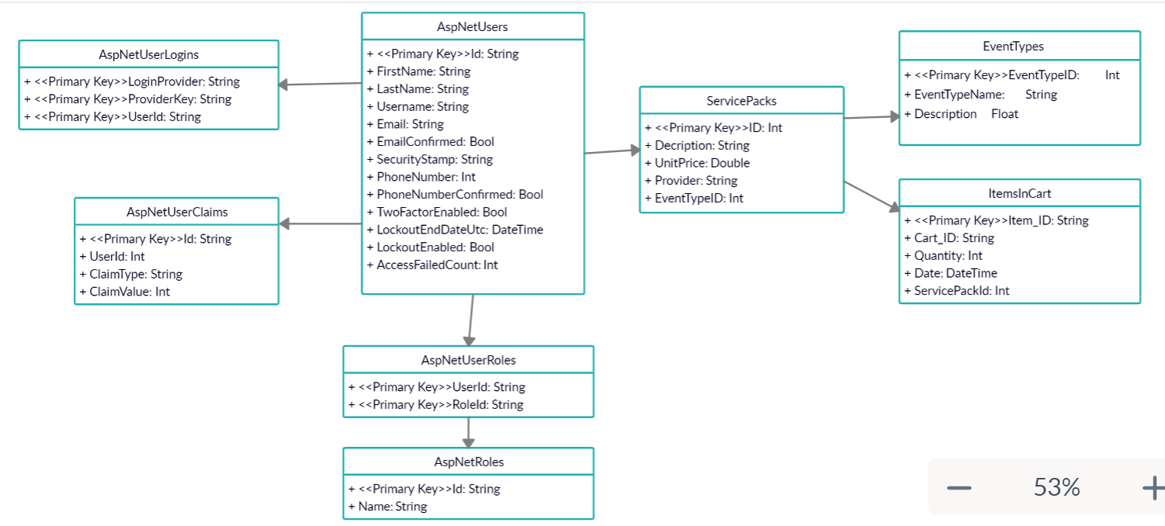

**Figure5.1**: The Class Diagram of Celebreno.

## 5.2 Flowchart

The flow chart is a method for system and process analysis. This leads to understanding the data flow in the web application “As shown in **Fig5.2**”. Celebreno Web Application allows only registered users to add service packages to the shopping cart. So firstly, the user should sign in the Web Application to select the event plan based on his demands. In case if the user is already registered, he can login directly using his username and password in the login form. Otherwise, if the user is new/ not registered, then he will have to fill his details in the registration form to complete the registration process.

In the login form, the application will validate the username and password, if they are valid, then the user will be signed in and redirected to the service packages web page. Otherwise, if the data entered by the user is not valid, the application will count it as an invalid login attempt. It the user exceeds five invalid login attempts, then his account will be locked out.

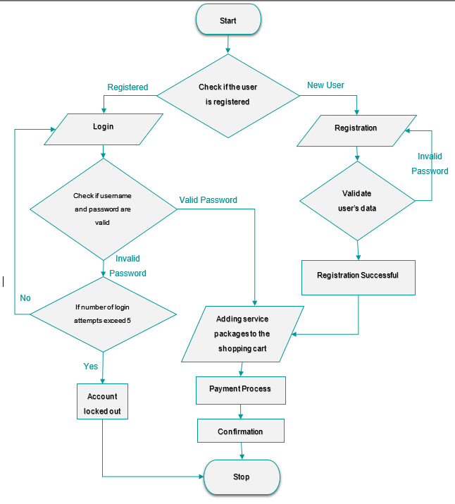In the registration form, the application will validate all the data entered by the user along with its constraints. All validation for inputs should be performed successfully in order to complete the registration process successfully. After the user selects the event plan, he will have to proceed to the online payment.

**Figure5.2**: The flow chart of buying a service package in Celebreno.

## 5.3 Interface Design

The interface design concentrates on expecting what users might need from the web application, as well as ensuring that the elements of the interface can be accessed easily. In order to design a good User Interface (UI) for the Celebreno Web Application, there are many aspects that should be taken into consideration like keeping the interface simple, using common UI elements to create consistency, and choosing colours and textures strategically. (Usability, 2019)

The figures below show the main user interfaces Celebreno Web Application. There are two types of user interfaces used in the application, which are Graphical User Interface (GUI) and Form-based user interface. **The Graphical User Interface (GUI)** is used for designing the whole application**. The Form-based** user interface is used in the registration form, login form, and administration and provider web page, where a number of text boxes, dropdown lists, grid views and buttons are used as well. As can be seen, **Fig5.3** shows the interface design of **the home page** of the application. In addition, it shows the navigation bars and the slider of the web application, along with the promotional statements “Make it a date to remember”. Beside in **Fig5.4**, **the login form** is shown, where users can register (Sign up) if they are not registered or log in to their accounts if they are already registered. In **Fig5.6**, **the administration web page** is shown, where admin can access the database of the application, and do data manipulation. Finally, the **“Our Services” web page** is shown in **Fig5.5**, where all service packages are displayed.

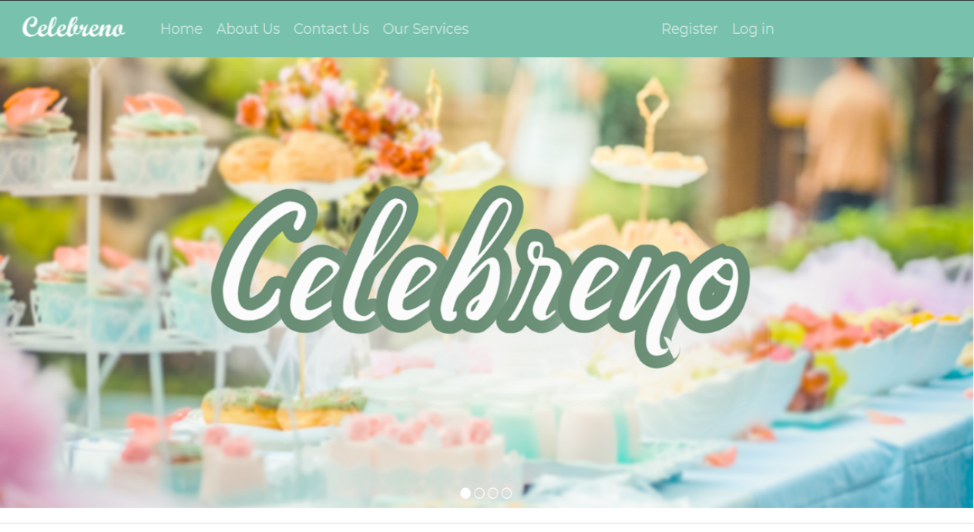

**Figure5.3**: The home page of Celebreno Web Application.

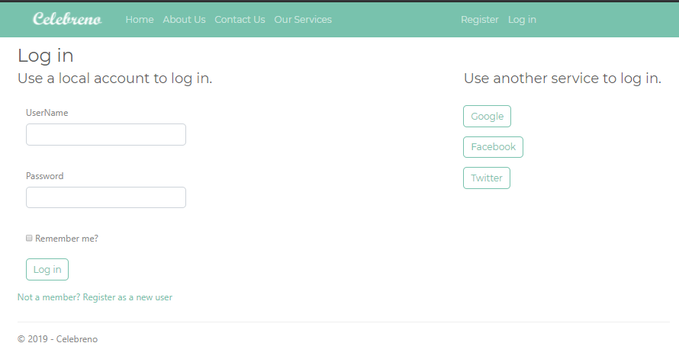

**Figure5.4**: The login form of Celebreno Web Application.

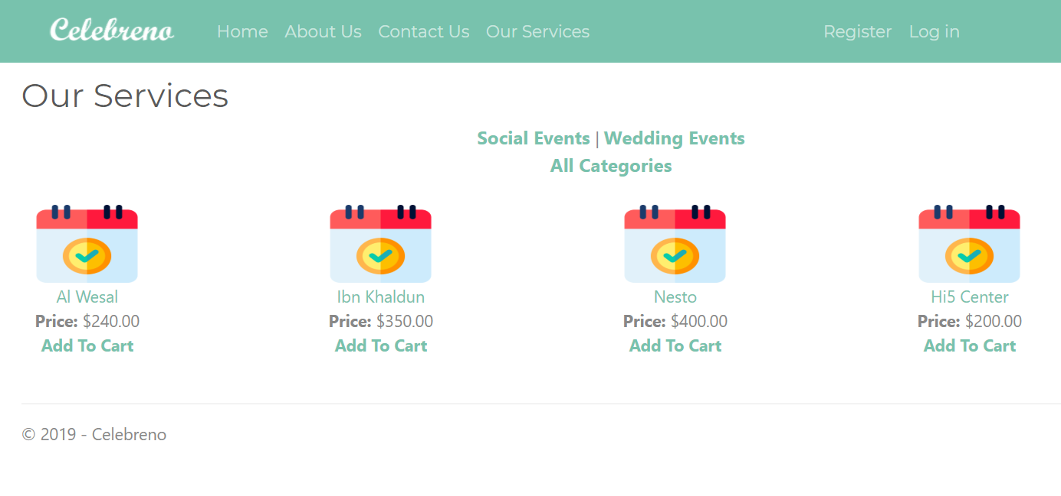

**Figure5.5**: Our Services Web Page of Celebreno Web Application.

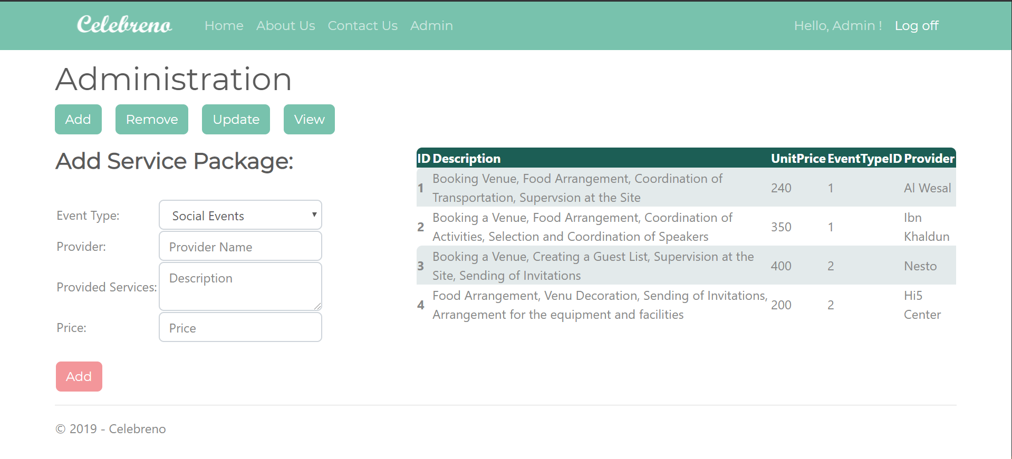

**Figure5.6**: The Administration Page of Celebreno Web Application.

# Chapter 6: implementation details

ASP.NET provides four main frameworks for web application developments which are ASP.NET Web Pages, ASP.NET MVC, ASP.NET WebForms and ASP.NET single Page Application. **ASP.NET Web Forms** Application is the one which is used for developing Celebreno. This framework provides a variety of ASP.NET features including maintaining the state of the application, which are going to be discussed below in details. WebForms also provides a great set of built-in functionality including the membership functionality (ASP.NET Identify), which is going to be discussed later in this chapter.

The following are some of the main techniques and features used for the development of Celebreno Web Application in Visual Studio 2017:

* **ASP.NET Identity (Membership Functionality)**

This feature provides the membership functionality for the application. ASP.NET Identity can be added when creating the web application by changing the authentication to “Individual User Accounts” or after the creation of the application by installing it as a “NuGet” package. It stores the users’ credentials in an auto-generated database. It creates a folder called account that includes all the web forms required for the registration in the application. It also provides validation needed for all user inputs. (ASP.NETTutorials, 2019) In addition, it allows using OpenID and OAuth that are used for providing external authentication such as Facebook, Twitter and Google. All these external providers are successfully implemented in Celebreno but unfortunately since Celebreno is not yet hosted, Google and Twitter are not allowing the user to sign in, however, Facebook is successfully signing in Celebreno users since Facebook does not require the application to be hosted. (Microsoft, 2019) In asp.net identity, entity framework code first migrations are used to make changes required in the membership database. This is used in order to add new fields like first and last name in the registration form of Celebreno. (Atten, 2013)

* **Adding User Roles and limit access**

There are three main types of users in Celebreno which are Customers, Providers and Admin. So in order to implement these roles, “RoleActions” class is created, which includes the admin and provider roles as well as the login credentials for them. After that, a folder is created for each role. Each folder includes a unique web page for the corresponding role and a web configuration file that specifies the authorization of that page. Authorization tag in the web “config” file specifies who can access the page and who cannot. Then, a modification has been made in the navigation bar in the master page to allow the admin and provider to access their own unique pages.

* **Entity Framework Code First and SQL Server Express Local DB**

Entity Framework is the concept of creating the database based on the written code or in the entity model classes. The figure below **“Fig6.1”** shows the approach of code first. It allows to manipulate and retrieve relational data as objects that are strongly typed. It contributes in reducing code blocks needed for creating databases and application access. It also enabling issuing queries using LINQ, which provides some patterns to update and query the data inside the database. (FrameworkTutorial, 2019)

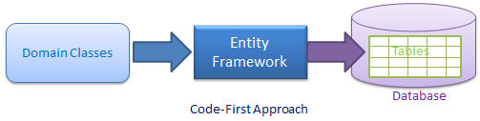

**Figure6.1**: The Code First Approach in Entity Framework.

(FrameworkTutorial, 2019)

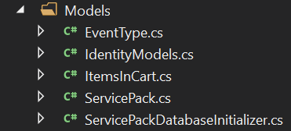In Celebreno, the data access layer is created using Entity Framework Code First, where a set of entity model classes are created “As shown in **Fig6.2”.** The “ServicePackDatabaseInitializer” class service contains the initially created service packages in the database. The “IdentityModels” class contains the definition of the context class of the database including the service packages and the user credentials data.

**Figure6.2**: The classes created for the database of Celebreno.

* **Master Pages**

Master pages are used in Celebreno to create a consistent layout for all the application’s web pages. It includes the navigation bar of the application which is fixed at the top of all the web pages. “ContentPlaceHolder” control is used in the master page, which will contain the content region for pages that uses the master page. (ValaVala, 2011)

* **Bootstrap**

Bootstrap is a theming and layout framework which is created by Twitter. It has many advantages including the responsive design, which plays a big role in the adaptability of the web application with different sizes of browser windows. (Smith, 2019) In Celebreno, the minty theme is used to redesign the user interface including all web server controls design. (BootsWatch, 2019)

* **WOW Slider**

WOW Slider is used to implement the slider in the home page of the Celebreno Application. It depends on CSS and JQuery, however, it can work without the need for JavaScript and “.js” calls. It is chosen because of many reasons, especially for its simplicity, responsiveness and its compatibility with all browsers. (WOWSlider, 2019)

* **Unobtrusive Validation**

All user inputs in Celebreno Web Application are validated using Unobtrusive Validation. This has been accomplished by using Validation Web Server Controls such as “RequiredFieldValidator” and “CutomValidator”. (Joshi, 2014)

* **State Management Technique**

In order to maintain the state of Celebreno web pages, Query String and Cookies are used. Query String is used in passing the values between the web forms such as the Service Package ID to display the corresponding details about that service package in the next page, and Cookies is mainly used in the registration process of Celebreno Users.

* **Error Handling and Logging**

Celebreno Web application is implemented in the way that it can handle different types of errors, as well as logging these errors for later review if needed. This technique enables to fix the errors in an easier way. In asp.net web applications, exceptions can be handled at three levels which are application level, page level, and code level. In Celebreno**, “ExceptionUtility” class** is created to handle and log the errors. The code in this class generates an exception log of errors called ”ErrorLog.txt” in the “App_Data” folder. In Celebreno, the **Application Level of Error Handling** is achieved by adding “custom errors” section in the web configuration file of the application, which specify the “ShowErrorPage.aspx” web page that will be loaded when an error occurs. Then, an application error handler is implemented in the “Global.asax” file. This will allow displaying the details about the error in the “ShowErrorPage.aspx” web page. In addition, a **Page Level of Error Handling** is implemented in the Home Page of Celebreno “Default.aspx” by declaring a page error handler in the code-behind of the page. Finally, the **Code Level Error Handling** in some of the application’s pages and classes such as “Actions_of_Cart” class using try catch statements.(Watson, 2017)

* **ELMAH**

ELMAH stands for Error Logging Modules and Handlers (ELMAH). It used and installed in Celebreno as a “NuGet” Package. It provides a log of all unhandled exceptions recorded. This log is displayed in a web page. (Hanselman, 2009) In Celebreno, this web page can be accessed using this URL: http://localhost:44371/elmah.axd

* **URL Routing**

In Celebreno Web application, the URL routing is customized in the “Global.asax” file of the application. This has been done to provide the Search Engine Optimization Functionality (SEO), as well as to define semantically significant URLs for users of Celebreno. In “Global.asax” file, two routes are added by calling the “MapPageRoute” Function. The two customized routes are for ServicePaclList.aspx and ServicePackDetails.aspx web pages, which their URLs include a query string (ServicePackage ID). URL Routing has the advantage of recognizing a URL that includes a query string, therefore if this URL is bookmarked, it can be working successfully even with the usage of the query string. (Microsoft, 2014)

* **Web Server Controls**

During the implementation of Celebreno Web Application, various web server controls are used including text boxes, buttons, dropdown lists, labels, validation controls, content place holder and navigation bar in the “master page”, list views in “ServicePackList” page, form view in “ServicePackDetails”, grid views in “admin”, “provider” and “ShoppingCart” pages and Multiview and views in “admin” and “provider pages.

# Chapter 7: Result and discussion

Celebreno Web Application was checked completely from end-to-end according to the testing criteria mentioned in the third chapter. The functionality, usability, interface, compatibility, performance and security testing were performed. The results of the testing show that the application is successfully implemented in the proper way. All internal and external links and navigation between pages were successfully checked. The application successfully validated all inputs and showed an error message for wrong inputs. Database consistency and manipulation were checked properly. The interface of the application is attractive and user-friendly. Moreover, the application is compatible with different browsers including Google Chrome, Microsoft Edge and Internet Explorer. The application loads successfully on different internet speed. Further, the application is secured properly and does not accept invalid inputs.

In the registration form “As shown **Fig7.1**”, the user enters his details to submit it and complete the registration process (create an account). The application will validate all the inputs in such a way that no missed or blank text box since all information is required to be entered. The RequiredFieldValidator is used to achieve this type of validation on all textboxes in the form. If the Username or the email entered by the user is already taken, an error message indicates that the value is already taken will be shown to the user. For the password, two validations will be checked:

* The matching of the password and confirm password fields, using CompareValidator.
* The criteria defined for string password will be checked, which is “Passwords must be at least 6 characters. Passwords must have at least one non letter or digit character. Passwords must have at least one digit ('0'-'9')”. The password validator is configured in the “IdentityConfig” class.

In the login form “As shown **Fig7.2**”, the user enters his username and password in order to log in his account. The application will validate that the required fields are entered using the RequiredFieldValidator. The data will be validated and verified with the help of asp.net identity feature. If the password is not correct, an error message “Invalid Attempt” will be shown to the user. The invalid attempts are counted. If the user exceeds five attempts, his account will be locked out. The configuration of the lockout is included in the “IdentityConfig” class. A “Remember me” checkbox is also used to allow the user to save his credentials for the next time. When the user logins in the next time he will not have to enter his credentials and log in again.

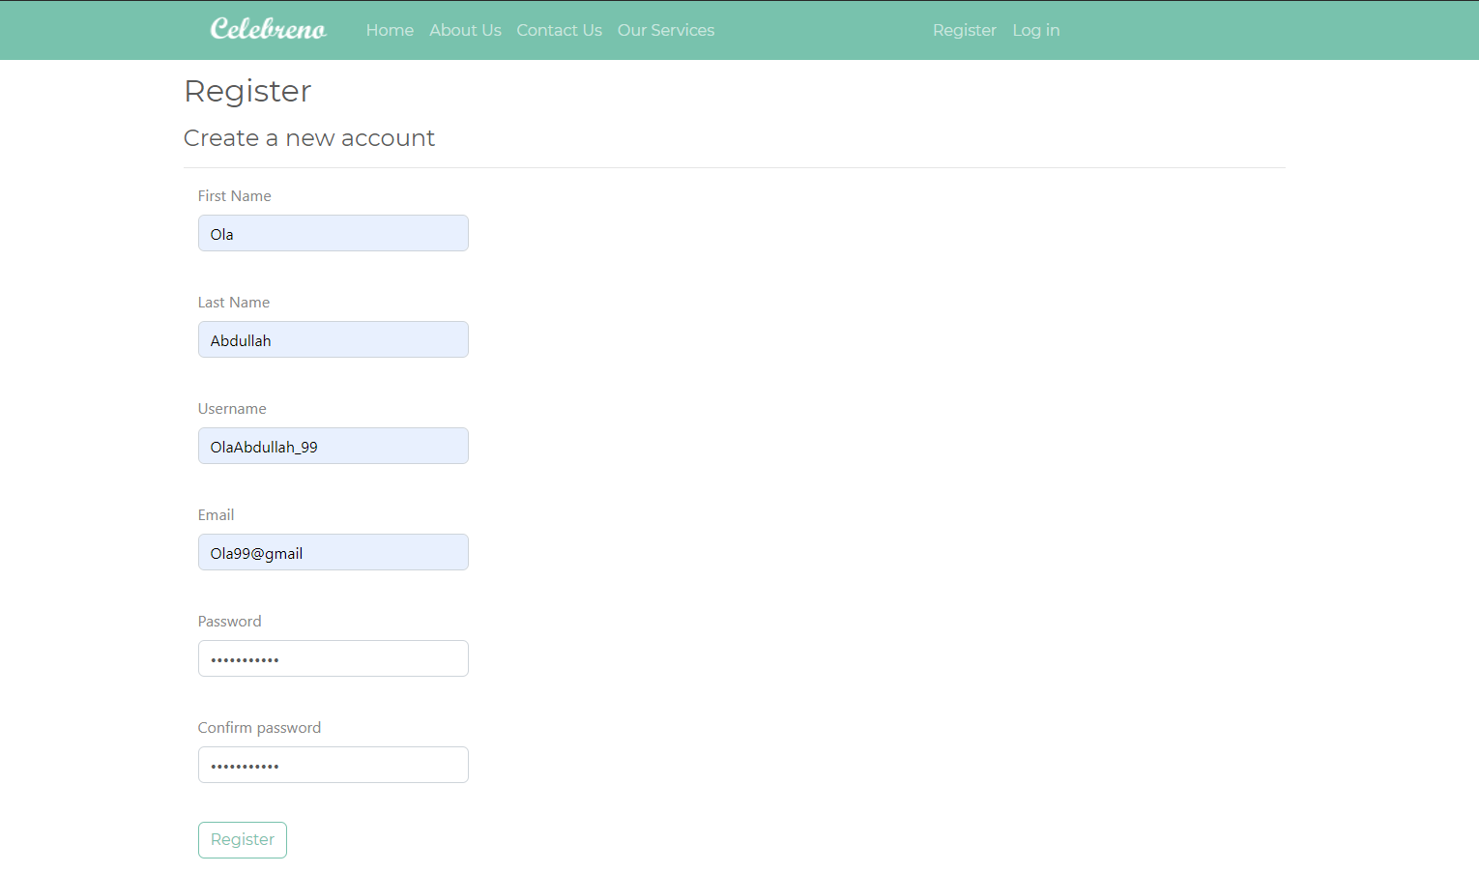

**Figure7.1**: The registration form of Celebreno.

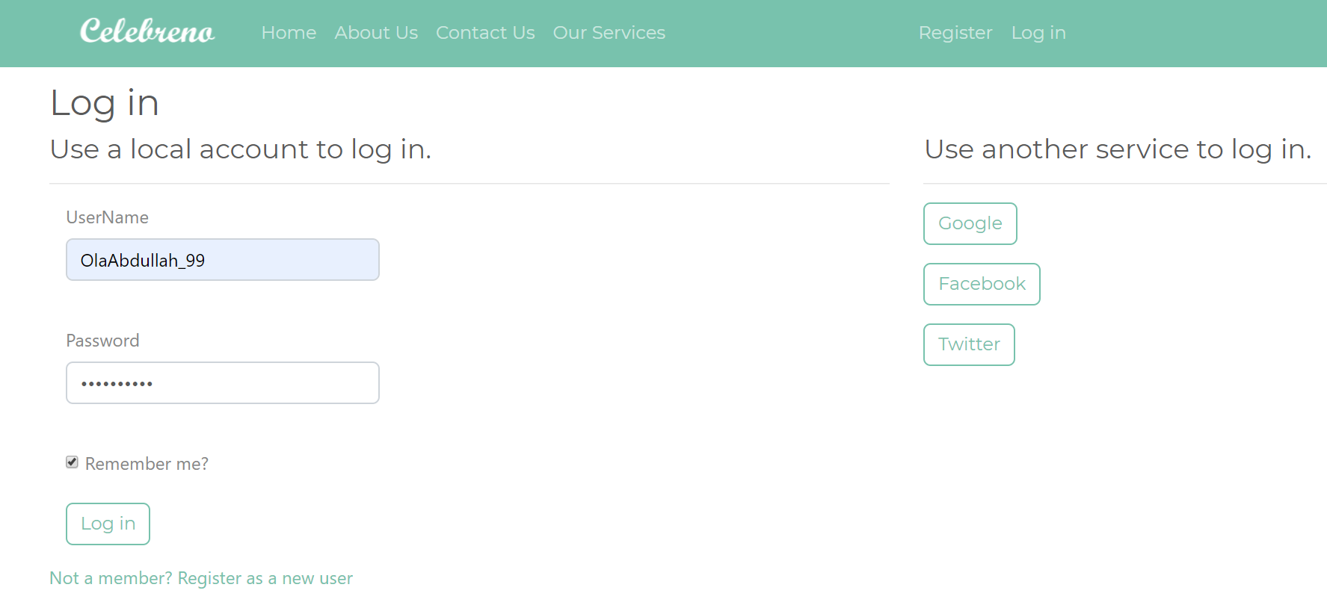

**Figure7.2**: The login form of Celebreno.

In the “Our Services” page, the user can select the type of the events to filter the service packages “As shown in **Fig7.3”.** When the user attempt to add a service package to the shopping cart, the application will check if the user is registered or not, if the user is registered the service package will be added to the shopping cart successfully and the user will be redirected to the “ShoppingCart” page “As shown in **Fig7.4”**, where the user can update the number of each item in the cart as well as remove an item, and then proceed to pay using Paypal. In case if the user is not login or registered in the application, the application will not allow the user to access the shopping cart and the user will be redirected to the login form. If the user is not registered at all, he can choose “Not a member? Register as a new user” option “As shown in **Fig7.1”**, to go the registration form page.

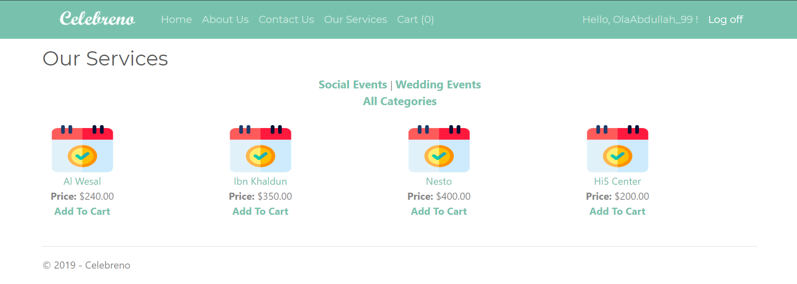

**Figure7.3**: Our Services Page of Celebreno.

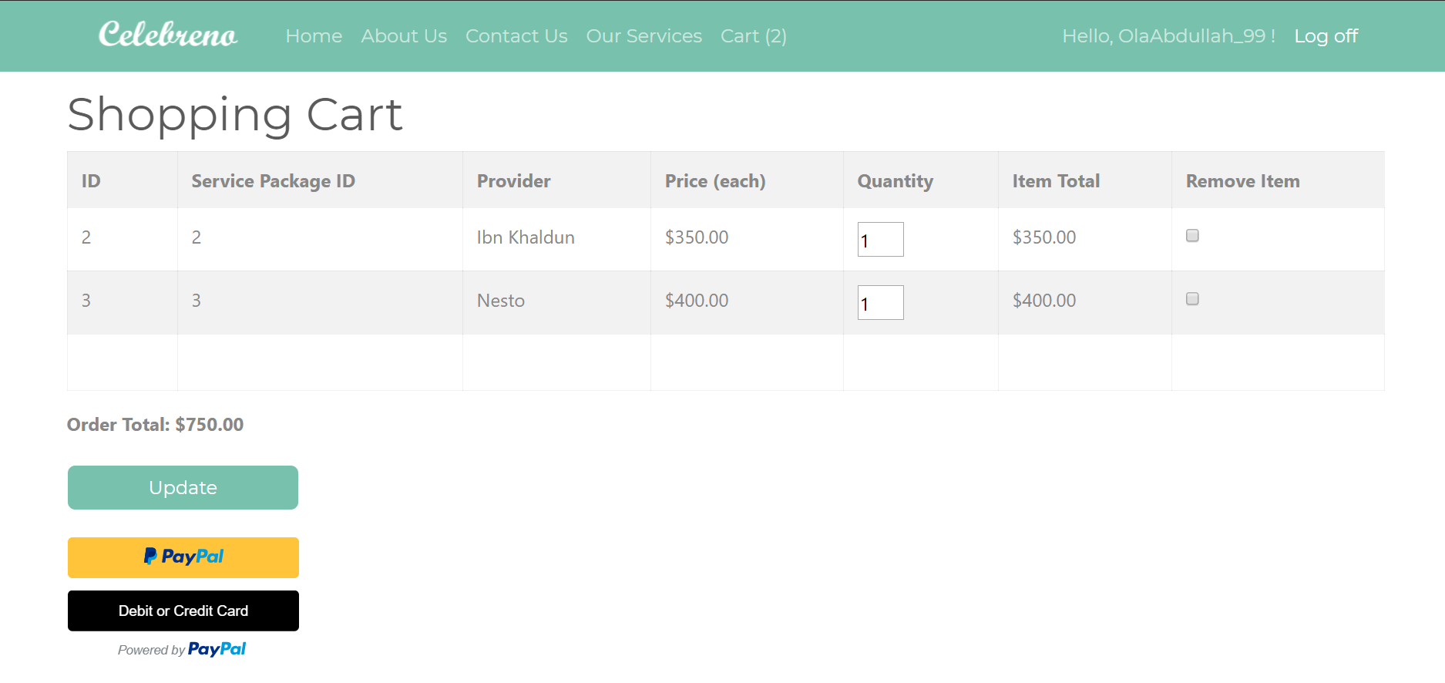

**Figure7.4**: The Shopping Cart of Celebreno.

In the administration page “As shown in **Fig7.5**”, the admin can access the database that contains all details about the service packages, and manipulate with it. The admin can add, remove, update and view the service packages. The application will validate all details entered in the controls by using control validations such as “RequiredFieldValidator” for checking blank fields and “RegularExpressionValidator” for checking the datatype in the description of service packages and the integers in the unit price field. If the user attempt to enter data other than strings, integers or commas in the description field such as spaces or special characters, a message will be displayed to the admin indicates the invalidation occurred.

ADO.Net was used to perform the updating of data in the same database. This demonstrates that it can be used along with Entity Framework Code First.



**Figure7.5**: The Administration Page of Celebreno.

# Chapter 8: Conclusion

In conclusion, this report discusses the development of an Event Planning Web-based Application, called Celebreno. A clearly defined aim, objectives, problem description, challenges, feasibility, significance, scope followed by, the general constraints and benefits of the project are provided. The main objectives of this project were successfully achieved. The application was successfully developed and providing online functionality of event planning was successfully achieved through implementing Celebreno Web Application. Furthermore, two previous important works along with their strengths and weaknesses are clearly reviewed and analysed. Then, the Agile Software Development LifeCycle (SDLC) Model, which used for the development of the project/web application was mentioned. As well as, the requirements of the application were specified clearly in terms of Business level, user level and product level requirements. In addition, the design of the project is illustrated using a database diagram, flow chart, and user interface. The implementation details including the database creation, the features and the techniques used in the application were discussed briefly. The report shows that Celebreno Web Application was successfully implemented and tested. This web application, as can be seen, would be a great way for people to resolve the issue of planning a cost-effective and successful event.

# Chapter 9: future work

Celebreno Web Application can be enhanced by incorporating a Chatbot into it, so that users of the web application can interact with the bot to get responses of their queries, for example asking about the cheapest or the top-rated among the services. Thus, the user experience will be improved. Furthermore, setting up Two Factor Authentication (2FA) using SMS or email would be great for the application to improve the security and to allow the functionality of forgetting password option. In addition, the application can be improved by adding search functionality for the whole content in the application. Finally, the most important thing to do further is to host the Web application to make it accessible worldwide and to take benefit of many features that are not available without hosting including adding a google search engine and aloe signing up with Google and Twitter as external provide

# References

AjayKumar, Taher & Kasture, 2018. *A study and implementation of event management system using smartphone*. In Journal of Emerging Technologies and Innovative Research 2018. Ahmadabad, April 2018. Ahmadabad: AjayKumar. pp. 1-4.

ASP.NETTutorials, 2019. *ASP.NET WebForms Tutorial.* [Online]. Available from: https://asp.net-tutorials.com/. [Accessed 19 Decemebr 2019].

Atten, J., 2013. *Code-First Migration and Extending Identity Accounts in ASP.NET MVC 5 and Visual Studio 2013.* [Online]. Available from: https://www.codeproject.com/Articles/674760/Code-First-Migration-and-Extending-Identity-Accoun. [Accessed 19 December 2019].

Binti & Ghani, 2016. *A generic web-based event* management system (GEMS). In UTM Computing Proceedings. Kula Lumpur, September 2016. Kula Lumpur: Binti. pp. 1-6.

BootsWatch, 2019. *Minty Theme.* [Online]. Available from: https://bootswatch.com/minty/. [Accessed 19 December 2019].

Existek, 2017. *SDLC Models Explained: Agile, Waterfall, V-Shaped, Iterative, Spiral | Existek Blog*. [ONLINE]. Available from: <https://existek.com/blog/sdlc-models/>. [Accessed: 1 October 2019].

FrameworkTutorial, E., 2019. *What is Code-First.* [Online]. Available from: https://www.entityframeworktutorial.net/code-first/what-is-code-first.aspx. [Accessed 19 December 2019].

Garima, 2019. *Why Business and Functional Requirements are Vital for a Project’s Success.* [Online]. Available from: https://www.netsolutions.com/insights/business-and-functional-requirements-what-is-the-difference-and-why-should-you-care/. [Accessed 19 December 2019].

Gleb, B., 2019. *How Do Free Mobile Apps Make Money?.* [Online]   
Available from: https://rubygarage.org/blog/how-do-free-apps-make-money. [Accessed 19 December 2019].

Hanselman, S., 2009. *ELMAH: Error Logging Modules and Handlers for ASP.NET (and MVC too!).* [Online]. Available from: https://www.hanselman.com/blog/ELMAHErrorLoggingModulesAndHandlersForASPNETAndMVCToo.aspx. [Accessed 20 December 2019].

Hyperion Development, 2018. *How to Handle Ethics Issues in Software Development*. [ONLINE]. Available from: <https://blog.hyperiondev.com/index.php/2018/07/17/how-to-handle-ethics-issues-when-youre-starting-off-in-software-development/>. [Accessed: 1 October 2019].

International Institute of Event Management, 2017. *What is Event Planning | International Institute of Event Management*. [ONLINE]. Available from: <https://institute-of-event-management.com/what-is-event-planning>. [Accessed: 1 October 2019].

Jamsheer K., 2018. *12 Best Software Development Methodologies with Pros & Cons*. [ONLINE]. Available from: <https://acodez.in/12-best-software-development-methodologies-pros-cons/>. [Accessed: 1 October 2019].

Javatpoint, 2019. *Agile Model - javatpoint*. [ONLINE]. Available from: <https://www.javatpoint.com/software-engineering-agile-model>. [Accessed: 1 October 2019].

Javatpoint, 2019. *The process of development in the agile model*. [ONLINE]. Available from: <https://www.aclweb.org/anthology/P17-4017>. [Accessed: 1 October 2019].

Joshi, N., 2014. *Working With Validation and Unobtrusive Validation in ASP.Net.* [Online]   
Available from: https://www.c-sharpcorner.com/UploadFile/4b0136/working-with-validation-and-unobtrusive-validation-in-asp-ne/. [Accessed 19 December 2019].

Kryzhanovska , A., 2019. *How to Make a Free Web App Earn You Money.* [Online]   
Available from: https://gearheart.io/blog/how-make-free-web-app-earn-you-money/. [Accessed December 19 2019].

Kukhnavets P., 2016. *Agile vs Waterfall: Pros and Cons, Differences and Similarities – GanttPRO*. [ONLINE]. Available from: <https://blog.ganttpro.com/en/waterfall-vs-agile-with-advantages-and-disadvantages/>. [Accessed: 1 October 2019].

Liew V., 2019. *Introduction to Visual Basic 2017*. [ONLINE]. Available from: <https://www.vbtutor.net/vb2017/vb2017_lesson1.html>. [Accessed: 2 October 2019].

Microsoft, 2014. *ASP.NET Routing.* [Online] . Available from: https://docs.microsoft.com/en-us/previous-versions/cc668201%28v%3dvs.140%29. [Accessed 19 December 2019].

Microsoft, 2019. *External Authentication Services with ASP.NET Web API (C#).* [Online] . Available from: https://docs.microsoft.com/en-us/aspnet/web-api/overview/security/external-authentication-services. [Accessed 19 December 2019].

Oden C., 2016. *Design and implementation of an online event management system - project topics*. [ONLINE]. Available from: <https://www.projecttopics.org/design-implementation-online-event-management-system.html>. [Accessed: 1 October 2019].

Rennie, 2018. *Top Problems Faced by Corporate Event Organizers/Planners*. [ONLINE]. Available from: <https://www.bbblanc.com/top-problems-faced-corporate-event-organizers-planners/>. [Accessed: 1 October 2019].

Smith, S., 2019. *Building Beautiful, Responsive Sites with Bootstrap.* [Online]   
Available from: https://jakeydocs.readthedocs.io/en/latest/client-side/bootstrap.html. [Accessed 19 December 2019].

Software Testing Help, 2019. *Web Application Testing Complete Guide (How to Test a Website)*. [ONLINE]. Available from: <https://www.softwaretestinghelp.com/web-application-testing/>. [Accessed: 1 October 2019].

Techopedia, 2019. *System Requirements.* [Online]   
Available from: https://www.techopedia.com/definition/4371/system-requirements. [Accessed 19 December 2019].

Tyagi G., 2018. *6 Stages of Software Development Process*. [ONLINE]. Available from: <https://www.synapseindia.com/6-stages-of-software-development-process/141>. [Accessed: 1 October 2019].

Usability, 2019. *User Interface Design Basics | Usability.gov*. [ONLINE]. Available from: <https://www.usability.gov/what-and-why/user-interface-design.html>. [Accessed: 2 October 2019].

ValaVala, K., 2011. *Master Page in ASP.NET.* [Online]   
Available from: https://www.c-sharpcorner.com/UploadFile/4ed419/master-page-in-Asp-Net/. [Accessed 19 December 2019].

Watson, M., 2017. *Best Practices for Error Handling in ASP.NET MVC.* [Online]   
Available from: https://stackify.com/aspnet-mvc-error-handling/. [Accessed 19 December 2019].

WorkFront, 2018. *The 6 project constraints and how to manage them.* [Online]   
Available from: https://www.workfront.com/blog/the-6-project-constraints. [Accessed 19 December 2019].

WOWSlider, 2019. *Why WOW jQuery Slider?.* [Online]   
Available from: https://wowslider.com/. [Accessed 19 December 2019].